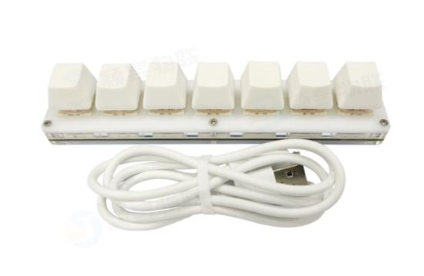
Hello guys, now I'm going to explain the use of the 7-key keyboard.
The 7-key version has two models respectively with and without lights, and the function mode is the same. Just something cool with a light.
Both the unlit and illuminated versions are driveless and can be used when connected.

First download the configuration software：https://itytsoft.com/7keySoft_EN.zip
The software package is downloaded and decompressed in the following directory. Double-click to run it yywl7Key.exe。

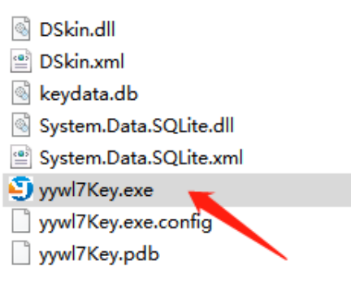

The configuration is divided into two areas
The left keyboard corresponds to 5 key Settings
On the right side, the device status configuration single light mode is saved to the keyboard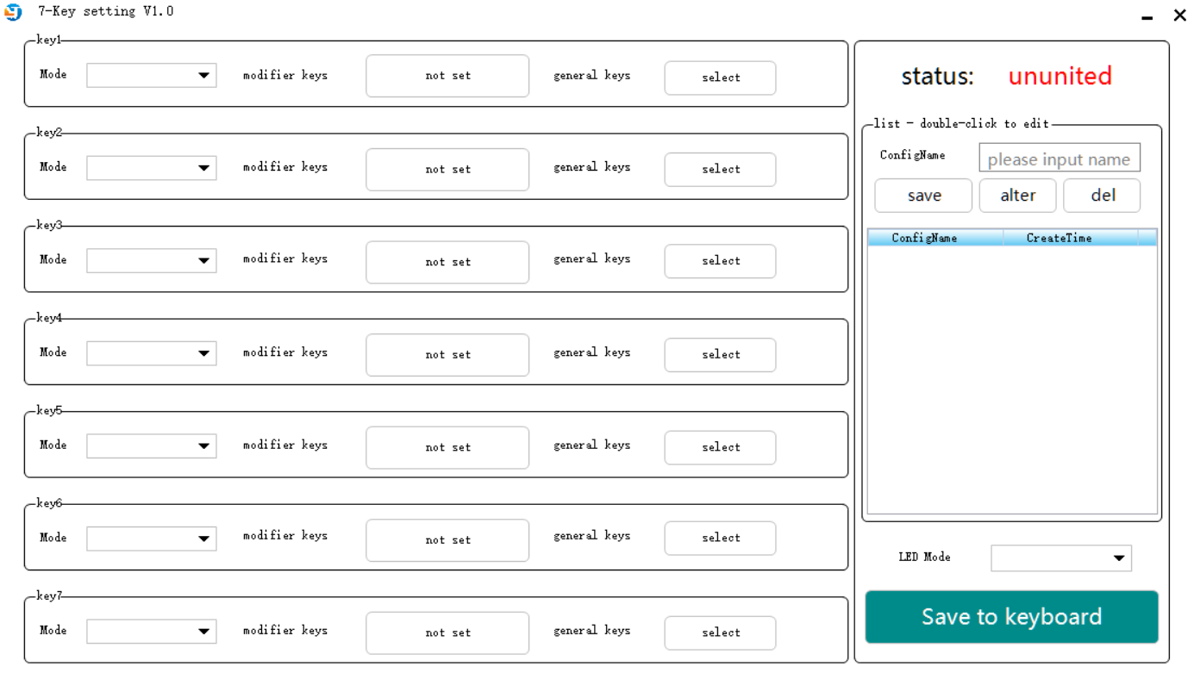

After the device is connected to the computer, there is a device state on the upper right of the software to observe whether the device is normally connected.
(Note: If it still shows no connection 10 seconds after connecting the computer, please restart the computer/replace the USB port and try again)

There are four modes keyboard mouse multimedia multikey。 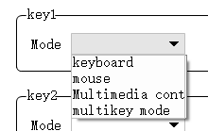

Several modes are completed by mouse click.
Note: Shift CTRL Alt multiple combinations just need to click on the selection.

The right area is the configuration list, which can be saved according to the configuration of the six buttons on the left. It is convenient to switch configuration keys quickly.

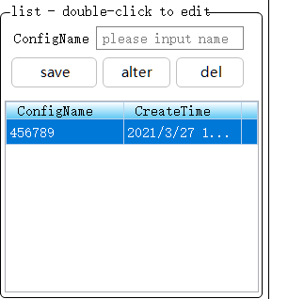

LED Mode：
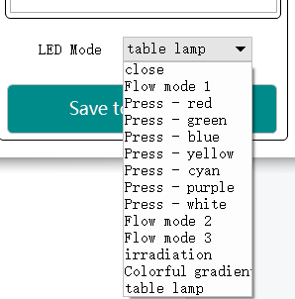

Finally is the lower right corner of the save to the keyboard prompt save successful OK completed!
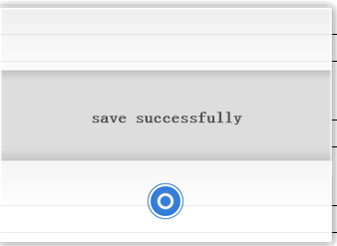

Tips: The configuration takes effect immediately after being saved to the keyboard. You do not need to remove or insert the configuration again.
After the configuration is complete, you can turn off the software to run, the keyboard can be without software, software is just a configuration tool.

For more help, please scan the wechat QR code below and contact our tech guy.

